**INTRODUCTION TO SINUSOIDAL**

**SIGNALS IN MATLAB**

**LAB # 06**



**Spring 2023**

**CSE301L Signals & Systems Lab**

Submitted by: **Ali Asghar**

Registration No. : **21PWCSE2059**

Class Section: **C**

“On my honor, as student of University of Engineering and Technology, I have neither given nor received unauthorized assistance on this academic work.”

Submitted to:

**Engr. Sumayyea Salahuddin**

Date:

**May 4, 2023**

**Department of Computer Systems Engineering**

**University of Engineering and Technology, Peshawar**

## Lab Objective(s):

Objectives of this Lab are;

* Generating Sinusoids
* Addition of Sinusoids with Variation in Parameters and their Plots
* Linear Phase Shift Concept When Dealing With Sum of Sinusoids

## Task # 01:

Generate the 1x10 row vector v whose i‐th component is cos (iπ/4).

**Problem Analysis:**

In the production and analysis of waves, vectors are important.

**Algorithm:**

* Take in vector parameters as given in problem statement.
* Run a for loop from 1 to 10 and save the ith component in ith column of Vec

**Code:**

**Output / Graphs / Plots / Results:**

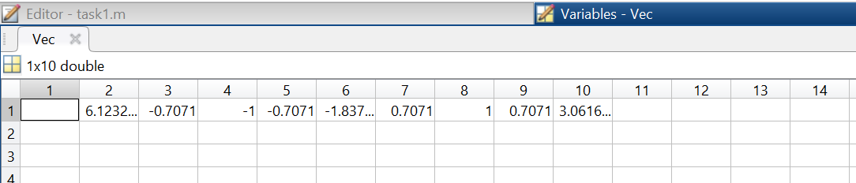

**Discussion and Conclusion:**

In MATLAB, we can generate vectors whose ith component is sinusoid.

## Task # 02:

Write matlab code that draw graphs of sin (nπx) on the interval ‐1≤x≤1 for n = 1, 2, 3, …, 8.

(Hint: Use for loop)

**Problem Analysis:**

For its analysis, wave simulation is needed. MATLAB allows us to simulate and create waves.

**Algorithm:**

* Create a vector of x-values from -1 to 1 using the `linspace()` function.
* Create a vector of n-values from 1 to 8.
* Create a new figure using the `figure()` function.
* Loop over the n-values using a `for` loop.
* Within the `for` loop, calculate the values of `y` for the current value of `n` using the `sin()` function and the x-values.
* Plot the `y` values against the `x` values using the `plot()` function with a line width of 2, and use `hold on` to add each line to the same plot.
* Label the x-axis and y-axis using the `xlabel()` and `ylabel()` functions.
* Set the title of the figure using the `title()` function.
* Add a legend to the figure using the `legend()` function with labels for each line.

**Output / Graphs / Plots / Results:**

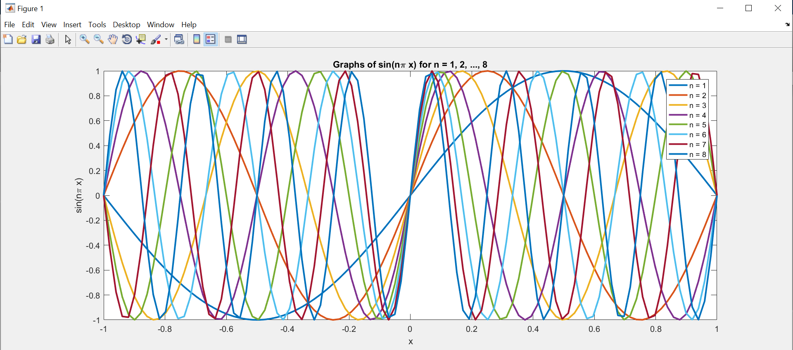

**Discussion and Conclusion:**

For its analysis, wave simulation is needed. MATLAB allows us to simulate and create waves.

## Task # 03:

Given the signal exp(‐x)sin(8x) for 0≤x≤2π, plot its continuous‐time and discrete‐time representations. Use subplot and label properly.

**Problem Analysis:**

The key concepts of signals and systems are continuous time and discrete time signals.

**Algorithm:**

* Define a vector of time values t using the 0:0.01:2*pi syntax.
* Define a continuous-time signal x as the product of exp(-t) and sin(8*t).
* Define the sampling frequency fs and sampling interval Ts.
* Create a vector of discrete-time values n using the 0:fs*2*pi-1 syntax.
* Sample the continuous-time signal x at the discrete-time values n using exp(-n*Ts).*sin(8*n*Ts).
* Plot the continuous-time signal x against t on the first subplot using the plot() function with a line width of 2 and labeled axes.
* Plot the discrete-time signal x_sampled against n on the second subplot using the stem() function with a line width of 2 and labeled axes.

**Output / Graphs / Plots / Results:**

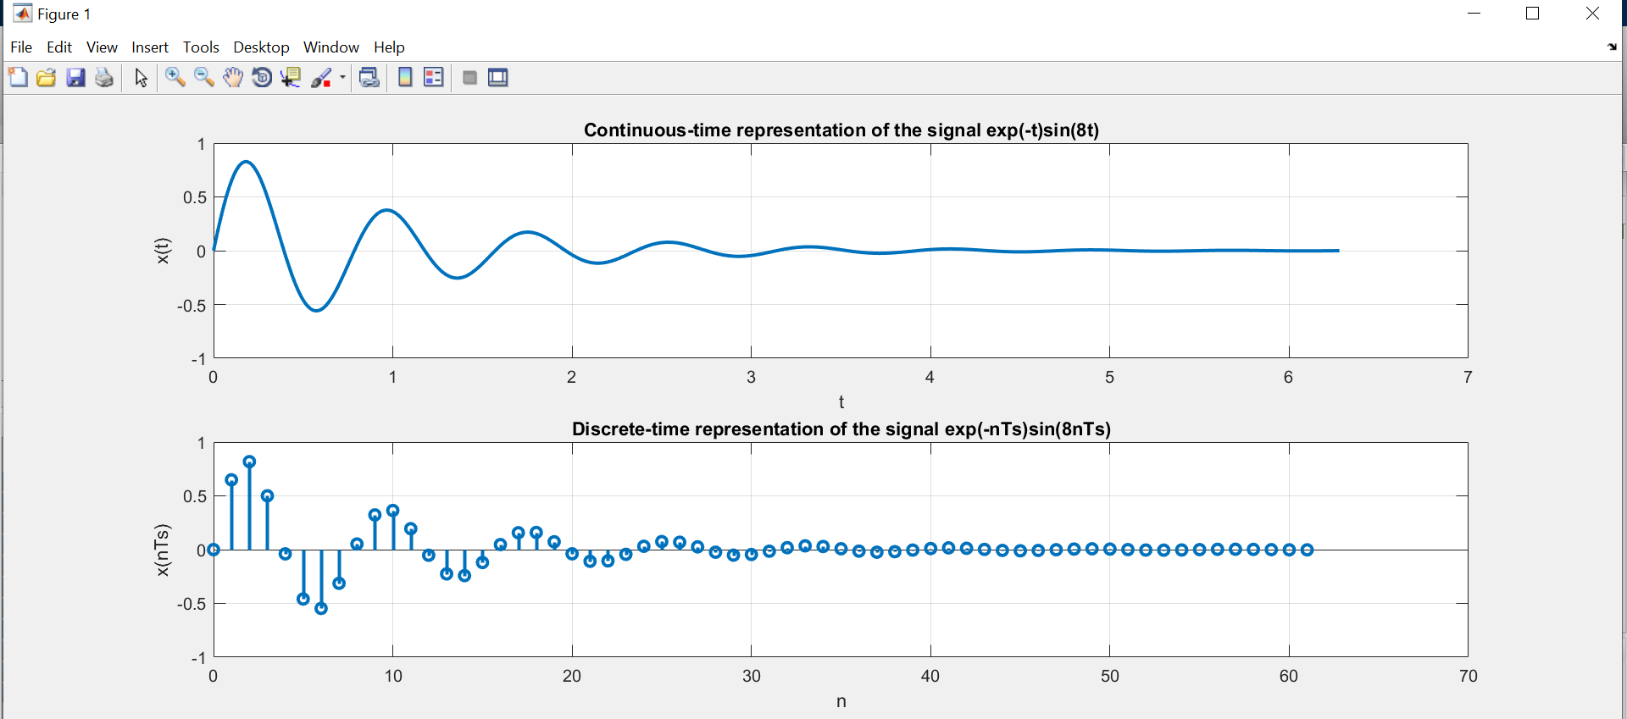

**Discussion and Conclusion:**

We can plot and visualize continuous and discrete time signals in MATLAB.

## Task # 04:

Modify the example given in topic 6.2 to generate a sine wave with phase shift of +pi/2. Then plot a cosine wave of same frequency, amplitude, and phase shift of 0 in another subplot. Compare both the signals and determine the relationship between the two.

**Problem Analysis:**

For different tasks, we may need sine and cosine waves with ranging/identical characteristics. That can be achieved in MATLAB.

**Algorithm:**

* Set the sampling frequency fs to 1000 Hz.
* Define the time vector t using -3:1/fs:3 syntax, which creates a time vector from -3 to 3 seconds with a step size of 1/fs.
* Set the amplitude A to 2, phase phase to pi/2, and frequency f to 1.
* Define x1 as a sine wave with amplitude A, frequency f, phase phase, and sampled at times t.
* Define x2 as a cosine wave with amplitude A, frequency f, phase 0, and sampled at times t.
* Create a new figure with two subplots arranged horizontally.

**Output / Graphs / Plots / Results:**

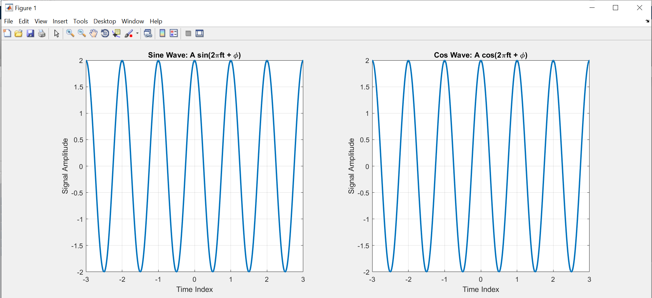

**Discussion and Conclusion:**

In MATLAB, sinousoidal waves can be generated continuously.

## Task # 05:

Write a program to generate a continuous‐time sine wave of frequency 3 Hz, positive phase shift of pi/2, and amplitude of 5. Also generate a continuous‐time cosine wave of frequency 3 Hz, amplitude of 5, and phase shift of 0. Plot the two signals on separate subplots and properly label them. Determine the relationship between the two signals

**Problem Analysis:**

We may need different characteristic sine waves for our different operations. We can do that in MATLAB.

**Algorithm:**

* Define the sampling frequency fs as 1000 Hz. and time vector t using the linspace function with a range of -1 to 1, and a step size of 1/fs and set the amplitude of the signals to 5.
* Define the first signal x1 as a sinusoidal wave with frequency 3 Hz and a phase shift of pi/2 radians.
* Define the second signal x2 as a cosine wave with frequency 3 Hz and no phase shift.
* The signals are now stored in variables x1 and x2.
* Create a new figure with two subplots arranged horizontally.

**Output / Graphs / Plots / Results:**

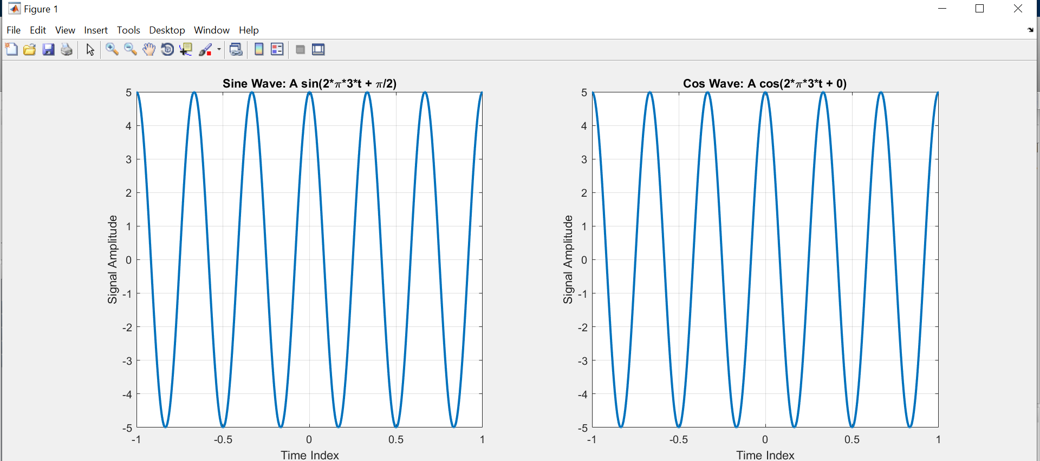

**Discussion and Conclusion:**

Generating continuous sinusoidal waves in MATLAB is possible.

## Task # 06:

Write a general program that takes ‘n’ sinusoids from user of same frequency, amplitude, and phase. Plot the individual sinusoids & the resultant using subplot function on same figure. Do perform proper labeling. Note: Take the amplitude, frequency, and phase given in example of case 1. Run the code for different values of n and state the result on paper.

**Problem Analysis:**

We frequently have to compare different sinusoids with different frequencies. That is possible in MATLAB.

**Algorithm:**

* Take in no, of sinusoidals.
* Input their varying parameters.
* Create these sinousoidals and subplot them.

**Output / Graphs / Plots / Results:**

For n = 2

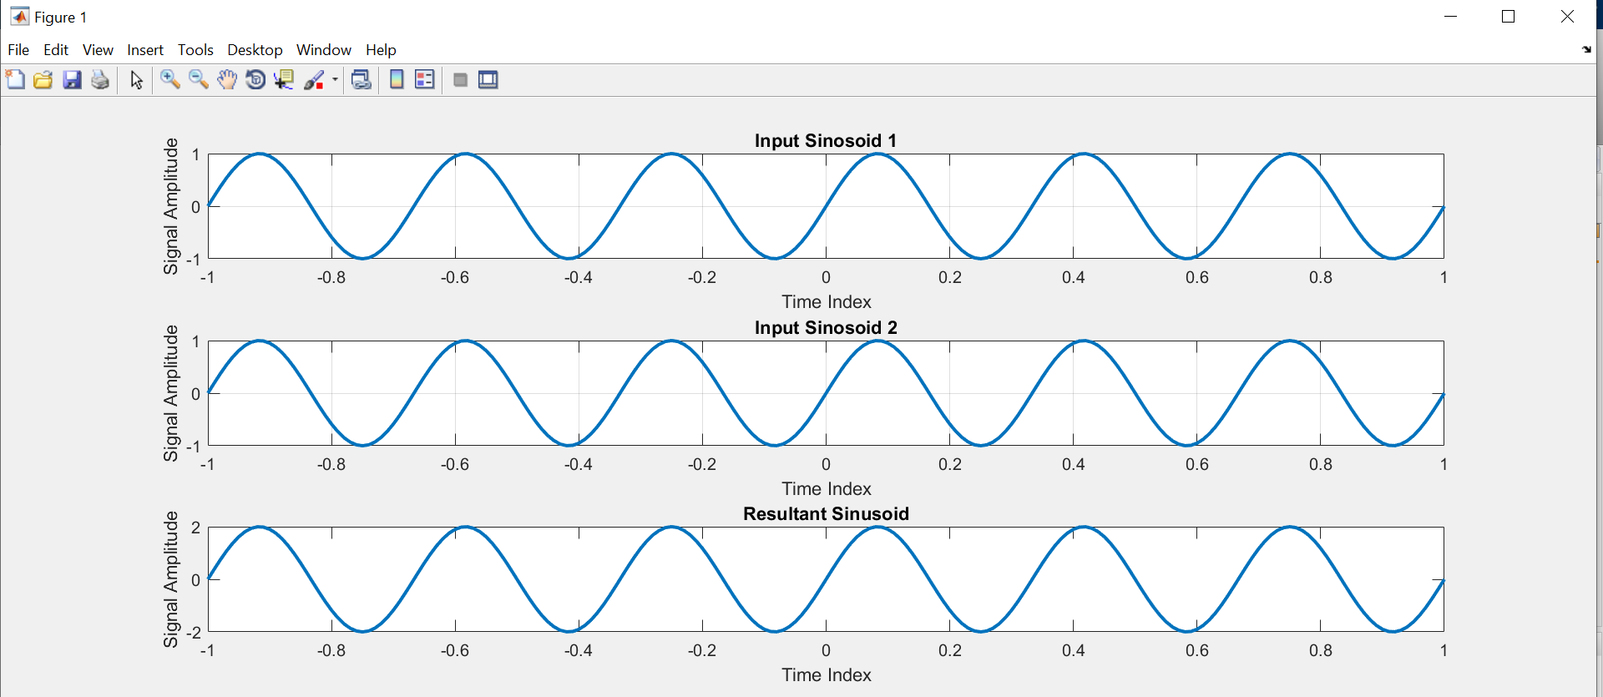

For n = 3

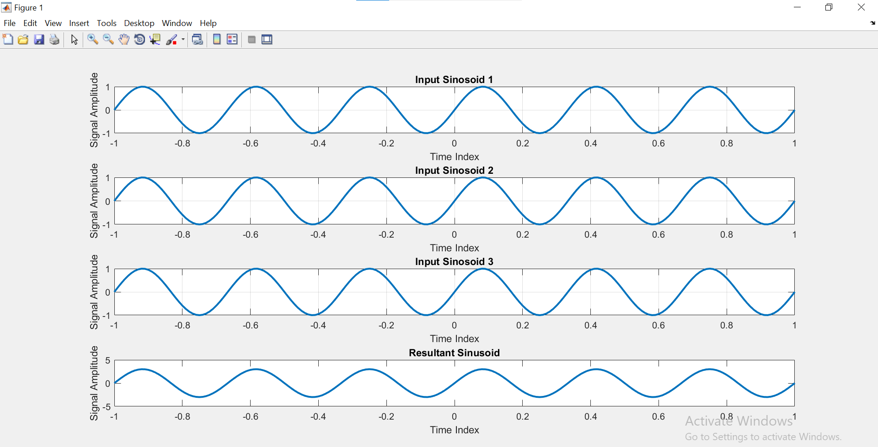

**Discussion and Conclusion:**

## Task # 07:

Write a general program that takes ‘n’ sinusoids from user of same frequency and phase with varying amplitudes. Take amplitude from user on run time. Plot the individual sinusoids & the resultant using subplot function on same figure. Do perform proper labeling. Note: Take the amplitude and frequency given in example of case 2. Run the code for different values of n and state the result on paper.

**Problem Analysis:**

We frequently have to compare different sinusoids with different frequencies. That can be accomplished in MATLAB.

**Algorithm:**

* Take in no, of sinousoidals.
* Input their varying parameters.
* Create these sinousoidals and subplot them.

**Code:**

**Output / Graphs / Plots / Results:**

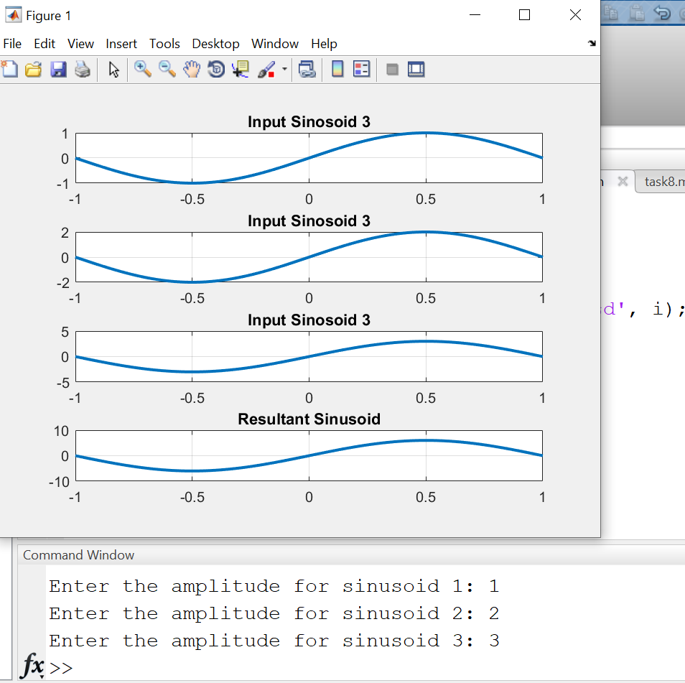

**Discussion and Conclusion:**

As a result, we can compare sine waves in MATLAB.

## Task # 08:

Write a general program that takes ‘n’ sinusoids from user of same amplitude and phase with varying frequencies. Take each frequency from user on run time. Plot the individual sinusoids & the resultant using subplot function on same figure. Do perform proper labeling. Note: Take the amplitude and phase given in example of case 3. Run the code for different values of n and state the result on paper.

**Problem Analysis:**

We tend to compare various sinusoids with different frequencies. That can be achieved in MATLAB.

**Algorithm:**

* Take in no, of sinousoidals.
* Input their varying parameters.
* Create these sinousoidals and subplot them.

**Code:**

**Output / Graphs / Plots / Results:**

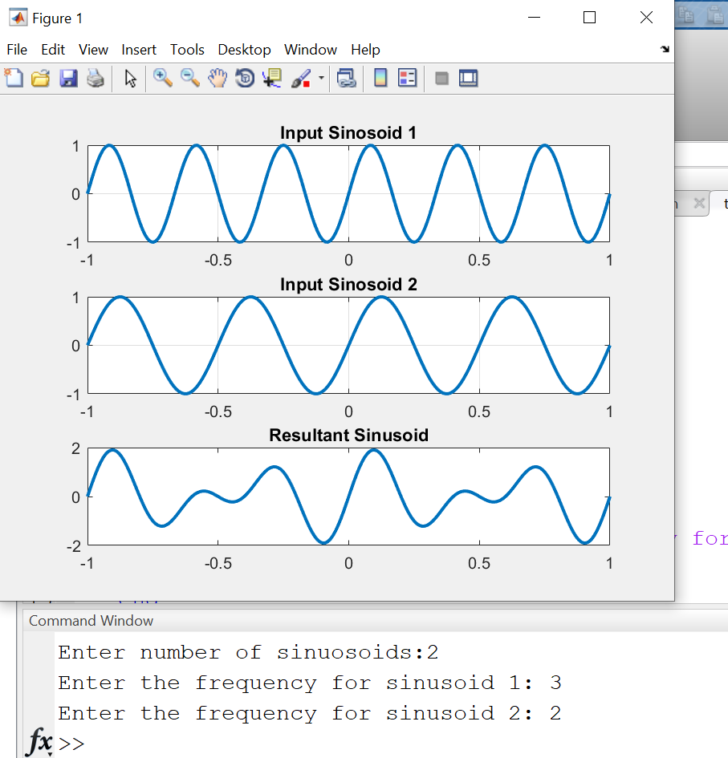

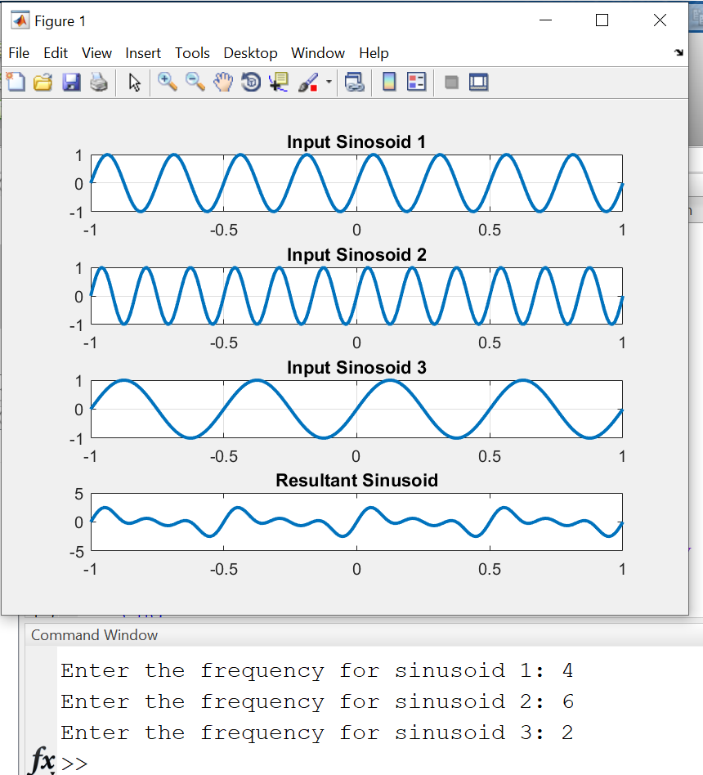

**Discussion and Conclusion:**

We frequently contrast distinct sinusoids with varying frequency. In MATLAB, that is achievable.

## Task # 09:

Write a general program that takes ‘n’ sinusoids from user of same amplitude and frequency with varying phases. Take each phase from user on run time. Plot the individual sinusoids & the resultant using subplot function on same figure. Do perform proper labeling. Note: Take the amplitude and frequency given in example of case 4. Run the code for different values of n and state the result on paper.

**Problem Analysis:**

We are frequently able to compare different sinusoids. That can be done in MATLAB.

**Algorithm:**

* Input no of sinusoidal.
* Create those sinusoidal with user input various phase shifts.
* Subplot all signals.

**Code:**

**Output / Graphs / Plots / Results:**

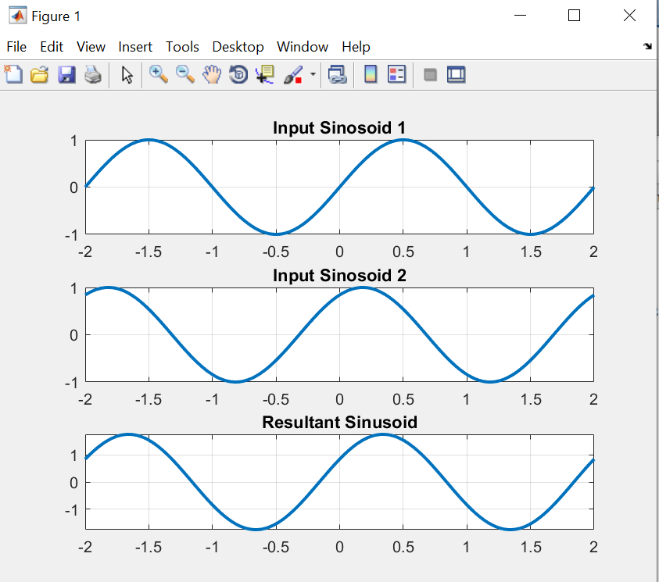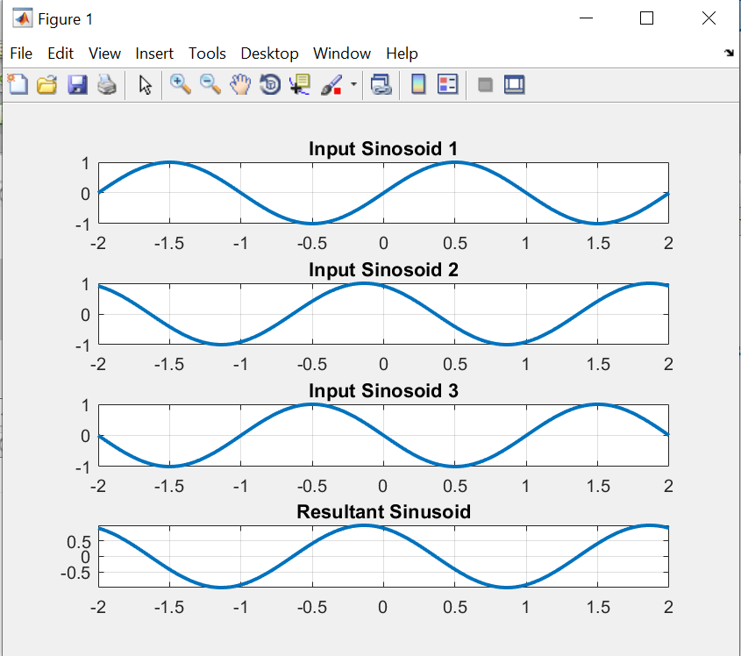

**Discussion and Conclusion:**

In MATLAB, we can quickly contrast various sinusoidal.